Spaces of hand
- Under normal conditions
  - NO well-defined spaces inside the fascial compartments
- 5 spaces – named
  - Midpalmar space
  - Thenar space
  - Web space
  - Pulp spaces
  - Forearm space of Parona
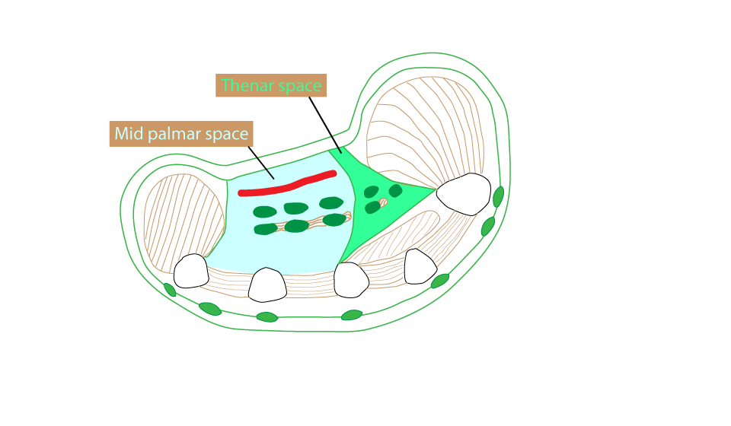

Midpalmar space

Boundaries:
- Superficially: palmar aponeurosis, superficial palmar arch, flexor tendons of medial three fingers covered with common synovial sheath (ulnar bursa) and medial three lumbrical muscles
- Deep: deep fascia covering interossei and metacarpal bones (3rd to 5th)
- Medially (ulnar): medial palmar septum
- Laterally (radial): midpalmar septum

Thenar space

Boundaries:
- Superficially: palmar aponeurosis, superficial palmar arch, flexor pollicis longus with flexor sheath (radial bursa) and first lumbrical muscle
- Deep: deep fascia covering adductor pollicis
- Medially (ulnar): midpalmar septum
- Laterally (radial): lateral palmar septum

[CLINICAL]Midplamar space and thenar spaces extend distally upto the distal palmar crease and beyond this they communicate with lumbrical canals. If there is collection of pus in midpalmar or thenar space (pus tanks), it can be drained via lumbrical canals (that acts as pus taps)

[TIP] Midpalmar space + thenar space = pus tanks
Lumbrical canals = pus taps, through web spaces

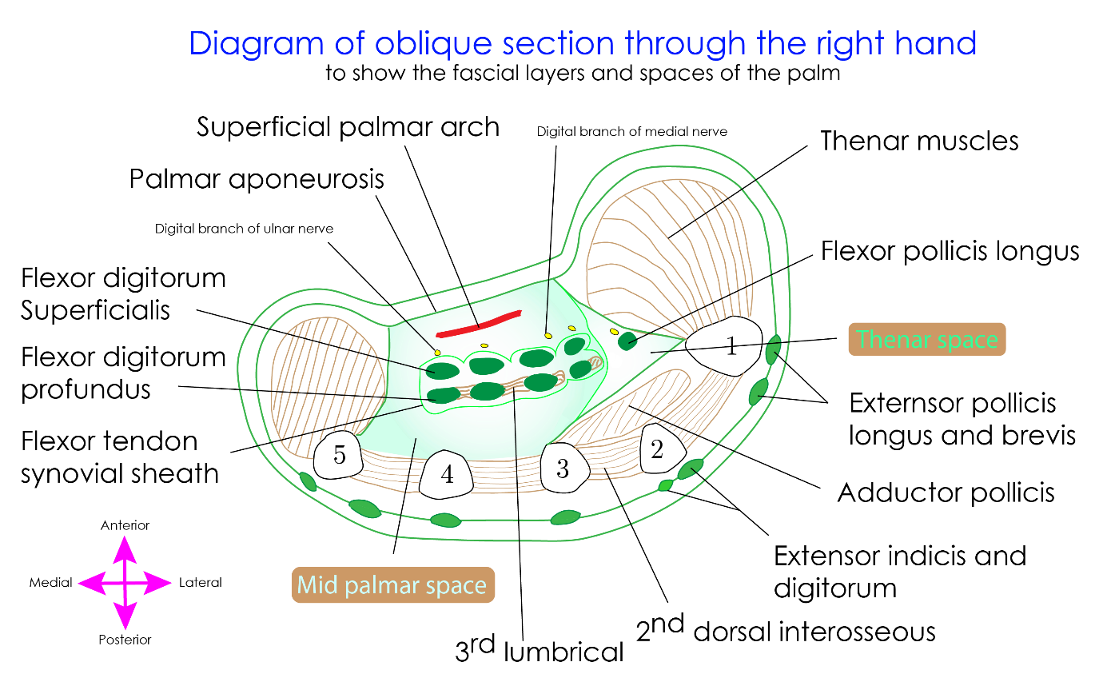

[TIP]Learn to draw the diagram
[YOUTUBE] https://youtu.be/m0DMUZhDP4s

Fibrous flexor sheaths
  - Thickened deep fascia
  - Extends from heads of metacarpal bones to distal phalanx
  - Consists of flexor tendons
    - Thumb – tendon of flexor pollicis longus
    - Other fingers – tendons of flexor digitorum superficialis and profundus
  - Tendons are covered by a synovial sheath – to allow frictionless movements
- Radial bursa – synovial sheath covering flexor pollicis longus; related to thenar space
- Ulnar bursa – synovial sheath covering long flexors of fingers – including 4 superficial and 4 deep flexor tendons.
- Usually- the distal end of ulnar bursa continues with digital synovial sheath of little finger
- Digital synovial sheaths – flexor tendons of digits while passing through the fibrous flexor sheaths are enclosed in synovial sheath.

Variations in arrangement of synovial sheaths
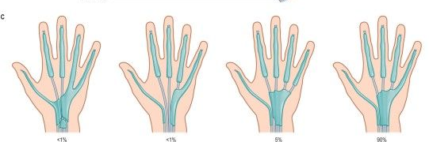

Tenosynovitis
Inflammation of synovial sheath surrounding a tendon
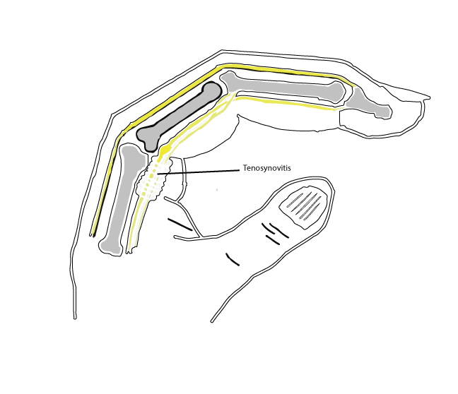

Web space
- Soft tissue between the bases of the fingers
- Distally - skin and natatory ligament
- Posteriorly - deep transverse metacarpal ligament
- Proximally - deep attachments of the palmar fascia, together with their lateral attachments to the tendon sheaths

Deep palmar space
- Complex three-dimensional space limited proximally by the carpal tunnel
- Lies deep to the palmar aponeurosis, between the radial and ulnar condensations of vertical fibres which connect the palmar aponeurosis to the thenar and hypothenar eminences
- Partitions that pass deeply from the longitudinal bands of the palmar aponeurosis form eight narrow compartments: four contain the digital flexor tendons and four contain the lumbricals and the neurovascular bundles

Pulp spaces
- Confined compartments bounded by the digital creases which overlie the joints
- Attached to the underlying pulleys
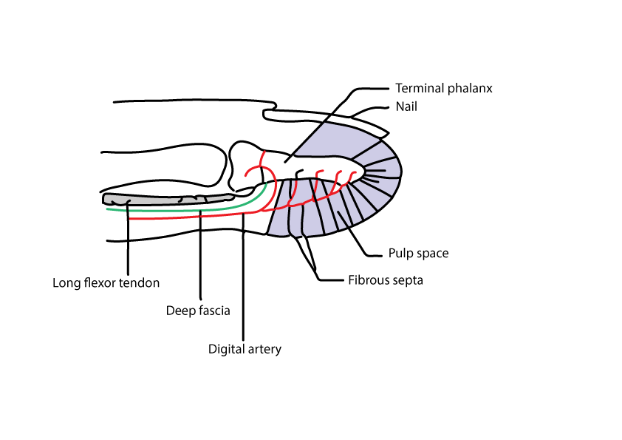

Forearm space of Parona
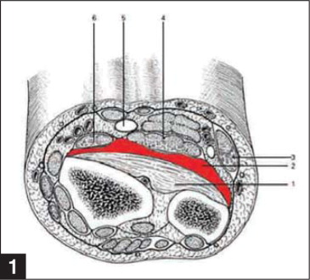
- Boundaries
  - Deep: pronator quadratus;
  - Superficial: flexor carpi ulnaris, flexor digitorum profundus, median nerve, flexor pollicis longus
  - Distally – continues with midpalmar space

Nail fold space
- ‘U-shaped' space
- Between eponychium and the lateral nail fold
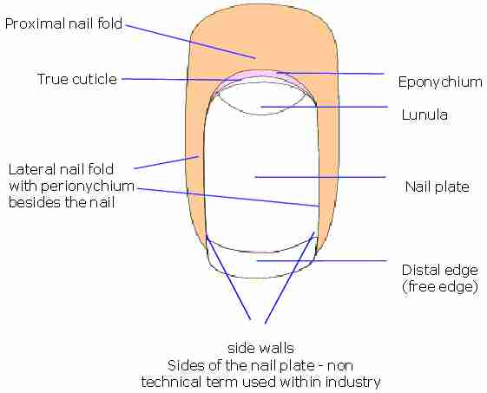

Infection in the hand
Effects of infection of hand can be devastating as it leads to severe pain and loss of functionality.
Pus can get collected in the deep palmar spaces – thenar or midpalmar space
Pus in these two spaces can be tapped via lubrical canals by passing into the web space
Pus can get accumulated in the finger
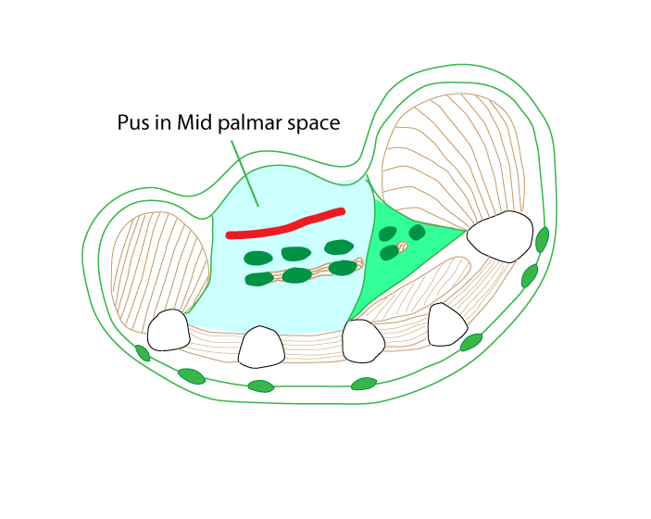
Paronychia – is infection of eponychium
Digital pulp space infection (or Felon, Whitlow) – is the infection of digital pulp space. Since it is a tight compartment, pus accumulation can cause severe pain. Infection can penetrate deep up to the bone.

___MCQ_START___
Q1. Which is the most common deep space of the hand involved in infections?
A. Pulp space
B. Web space
C. Thenar space
D. Midpalmar space [CORRECT]
___
Q2. The thenar space of the hand lies:
A. Between palmar aponeurosis and flexor tendons
B. Between flexor tendons and metacarpals
C. Lateral to the midpalmar space, beneath the thenar muscles [CORRECT]
D. Between dorsal interossei muscles
___
Q3. The midpalmar space is located:
A. Between skin and palmar aponeurosis
B. Deep to flexor tendons of medial three digits [CORRECT]
C. Lateral to flexor pollicis longus tendon
D. Between dorsal interossei muscles
___
Q4. Infection of the pulp space of a finger is termed:
A. Felon [CORRECT]
B. Whitlow
C. Paronychia
D. Ganglion
___
Q5. Which space of the hand is most likely to be involved in a “collar button” abscess?
A. Pulp space
B. Web space [CORRECT]
C. Thenar space
D. Midpalmar space
___
Q6. The midpalmar space communicates proximally with which anatomical space?
A. Thenar space
B. Subcutaneous space
C. Space of Parona [CORRECT]
D. Anatomical snuffbox
___
___MCQ_END___

